1. **C LANGUAGE:-**

**#include<stdio.h>**

**main()**

**{**

**printf("Hello World");**

**}**

**//Output:- Hello World**

1. **PYTHON:-**

**print("Hello World")**

**#Output:- Hello World**

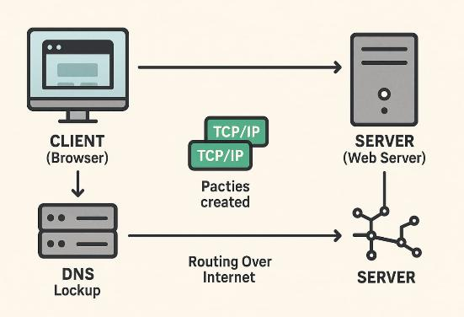

**HTTP server:-**

**import http.server**

**import socketserver**

**PORT = 8000**

**Handler=http.server.SimpleHTTPRequestHandlerwithsocketserver.TCPServer(("", PORT), Handler) as httpd:**

**print("Serving at port", PORT)**

**httpd.serve_forever()**

**HTTP client-server**

**import http.clientconn = http.client.HTTPConnection("localhost", 8000)**

**conn.request("GET", "/index.html") *# Request a specific file***

**response = conn.getresponse()**

**print(f"Status:{response.status},Reason:{response.reason}")**

**print(response.read().decode())**

**conn.close()**

1. 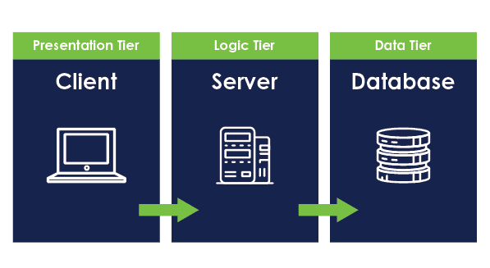
2. **Create file:  
   main.py**

**print("Hello, GitHub!")**

1. **Upload to GitHub:**
   * **Go to** [**GitHub**](https://github.com)
   * **Click "New repository" → Name it → Create**
   * **Click "Add file" → "Upload files"**
   * **Choose main.py → Click "Commit changes**

* **✅ File is now on GitHub!**

1. **Initialize & link remote (if not done):**
2. **git init -b main**
3. **git remote add origin <repo-URL>**
4. **First push:**
5. **git add .**
6. **git commit -m "init"**
7. **git push -u origin main**
8. **For updates:**
9. **git add .**
10. **git commit -m "msg"**
11. **git push**

* **Go to** [**https://education.github.com**](https://education.github.com)
* **Apply for GitHub Student Pack (use school email or ID)**
  + 1. **Create Project Repo:**
* **Click New Repository → Name it (e.g., student-project) → Create**
  + 1. **Collaborate:**
* **Go to repo → Settings > Collaborators**
* **Add classmate's GitHub username → Invite**

1. **Follow a GIT tutorial to practice cloning, branching, and merging repositories.**

* **Clone**
  + **git clone https://github.com/user/repo.git**
* **Branch:**
  + **git checkout -b new-feature**
* **Merge:**
* **git checkout main**
* **git merge new-feature**

1. 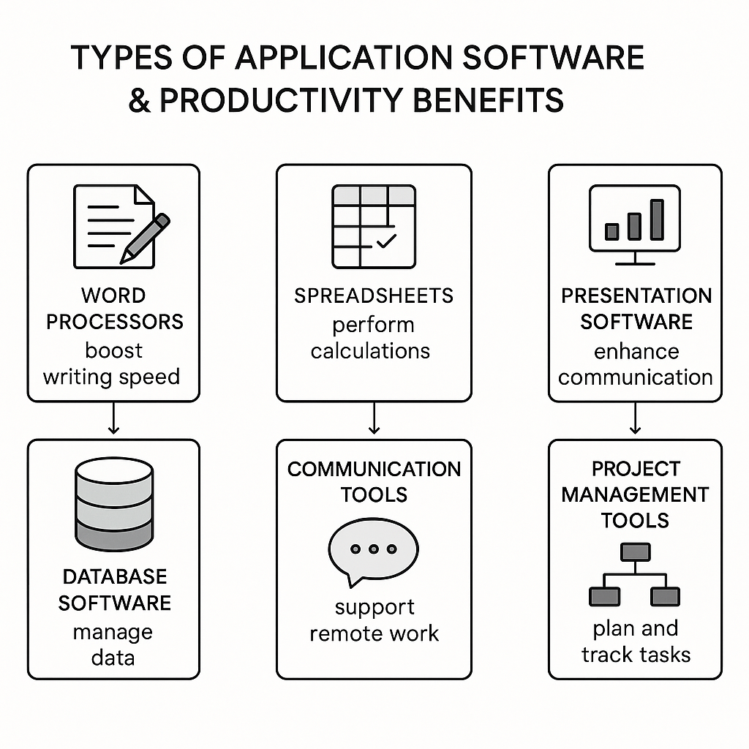

**1. Word Processors (e.g., MS Word)**

* **Help create, edit, and format documents**
* **Boosts writing speed and document sharing**

**2. Spreadsheets (e.g., MS Excel)**

* **Perform calculations and data analysis**
* **Increases accuracy and speeds up tasks**

**3. Presentation Software (e.g., PowerPoint)**

* **Create slides for communication**
* **Enhances clarity in meetings**

**4. Database Software (e.g., MS Access)**

* **Store and manage large data sets**
* **Saves time in data retrieval**

**5. Communication Tools (e.g., Zoom, Email)**

* **Enable instant messaging, video calls**
* **Supports remote work and faster decision-making**

**6. Project Management Tools (e.g., Trello, Asana)**

* **Plan and track projects**
* **Improves time management and teamwork**

**✅ Conclusion:  
Application software simplifies tasks, automates work, and increases overall productivity.**

1. 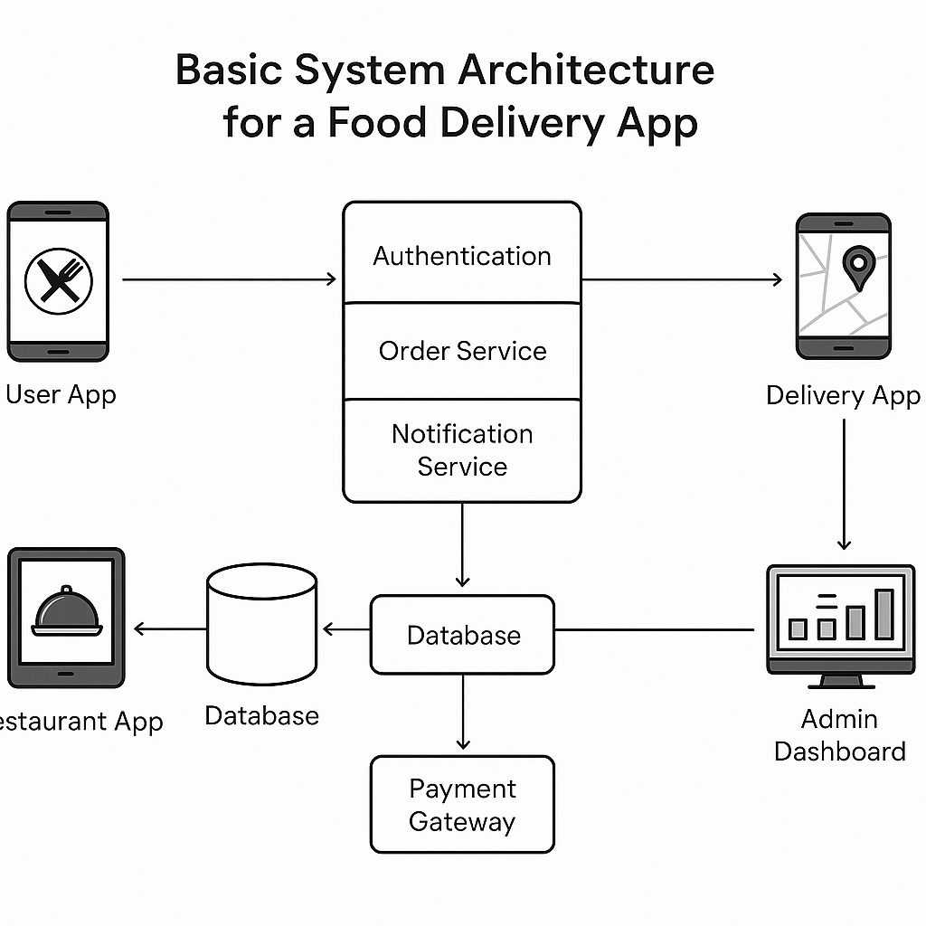

* **Addition: 2 + 3 → 5**
* **Subtraction: 5 - 2 → 3**
* **Multiplication: 4 * 2 → 8**
* **Division: 8 / 2 → 4**
* **Divide by Zero: 5 / 0 → error/exception**
* **Negative Numbers: -3 + 2 → -1**
* **Decimal Support: 2.5 + 0.5 → 3.0**

1. **A diagram of a pharmacy process

   AI-generated content may be incorrect.**

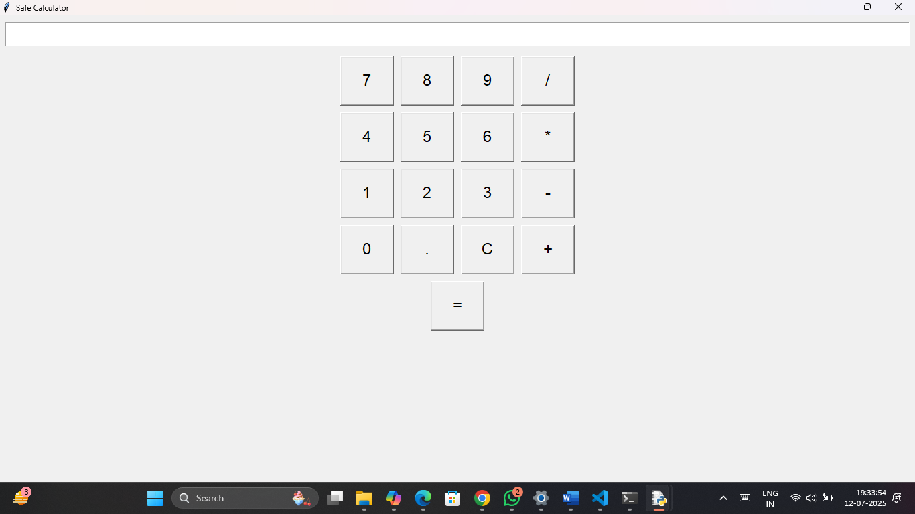

1. 